Camera free-motion view(KEYBOARD_2 and _1 to change free)

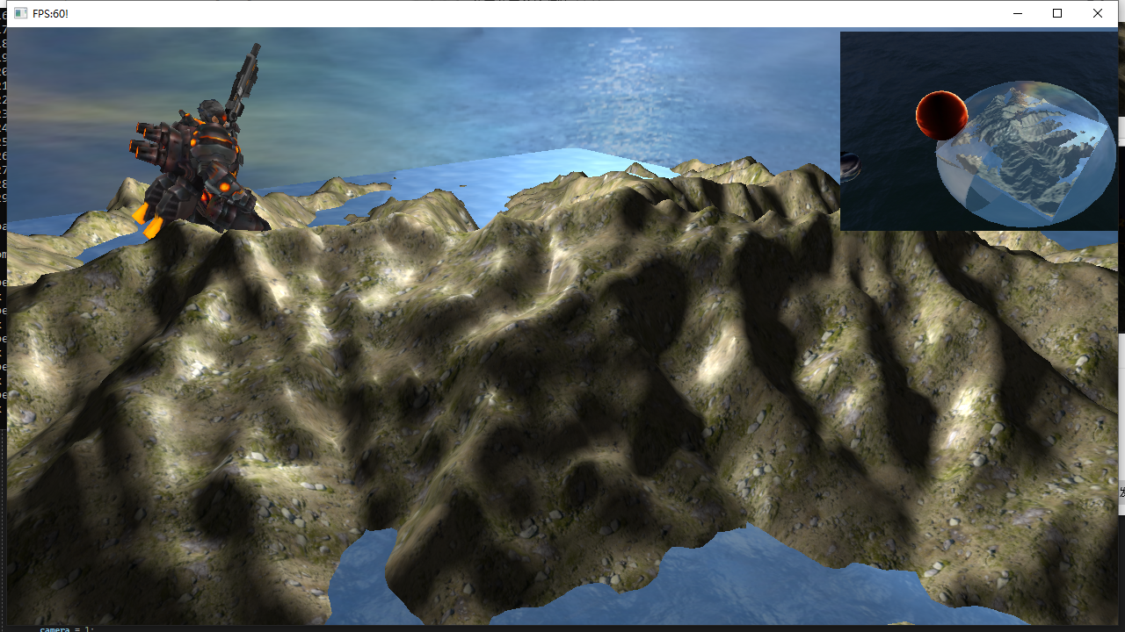

Camera view that follows the movement of the soldier(KEYBOARD_3)

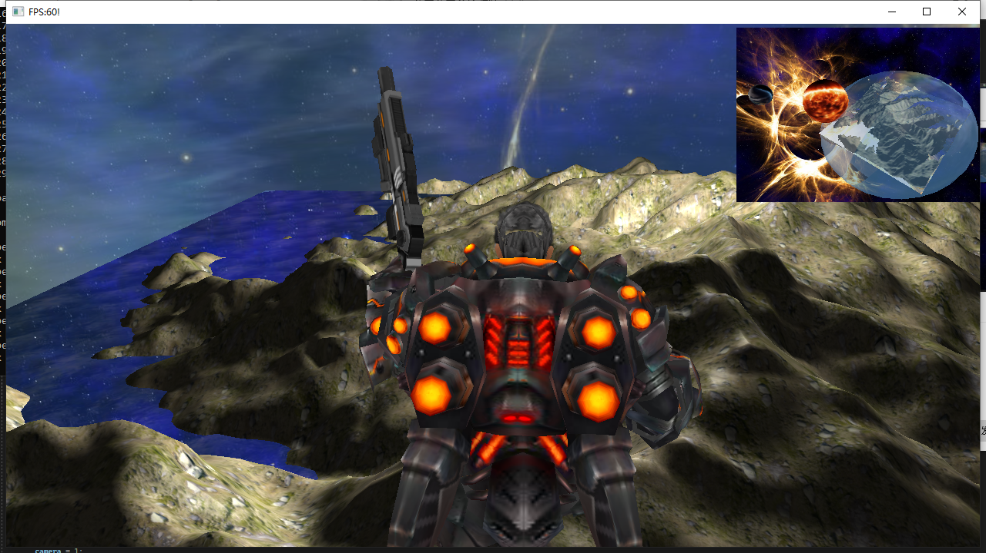

Overhead view of the camera at high altitude(KEYBOARD_4)

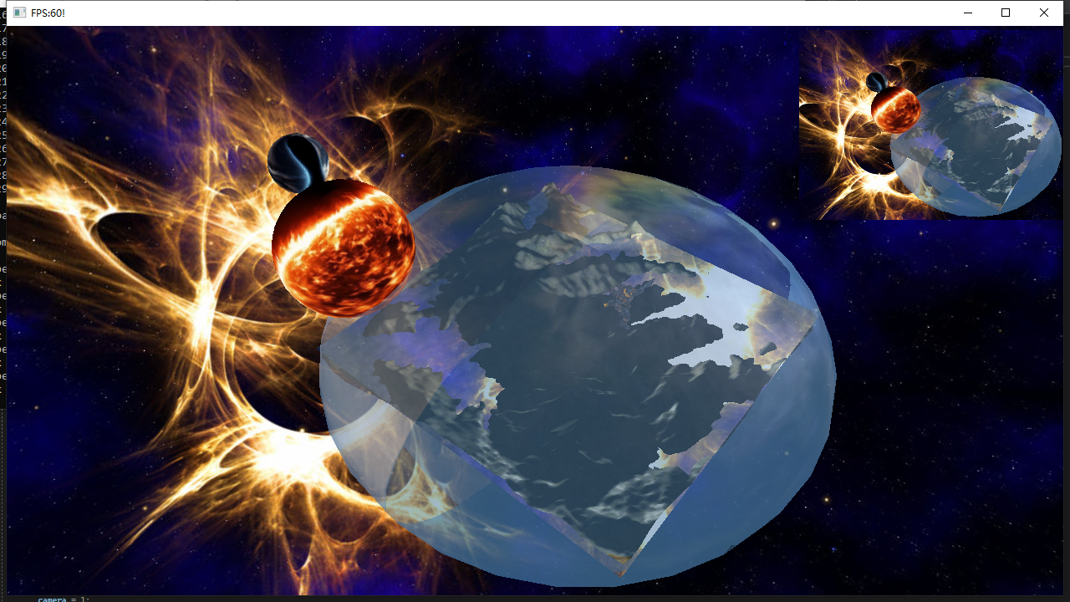

Update the sky box(KEYBOARD_9)

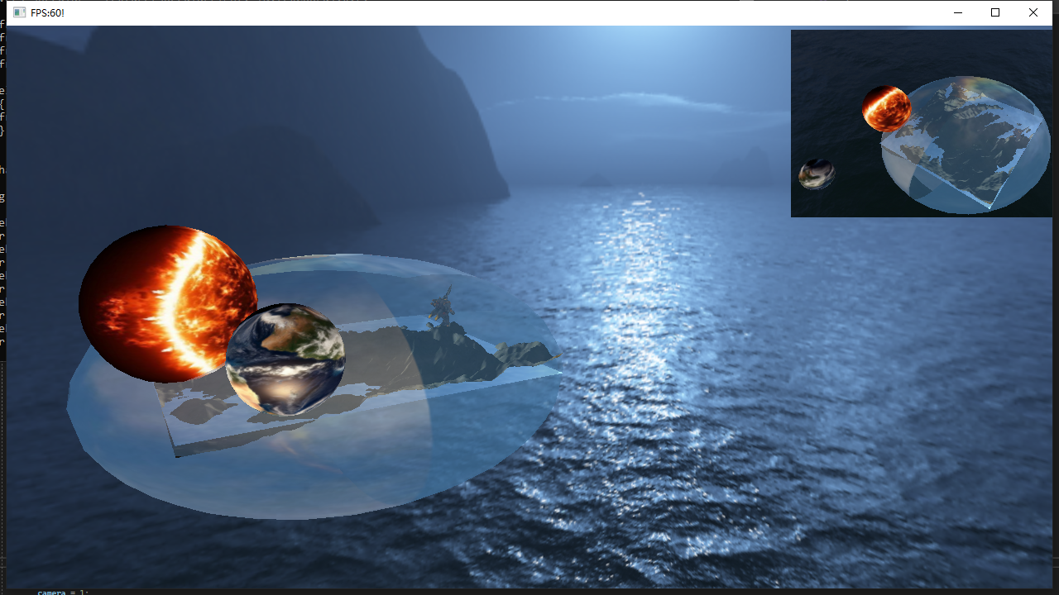

Multi-point random light effect（KEYBOARD_6）

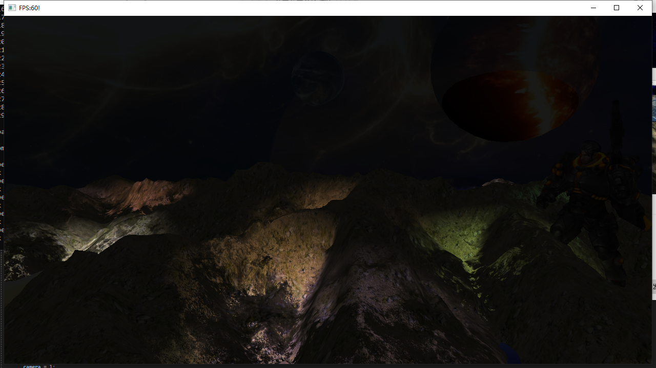

alternation of day and night（keyboard up and down）

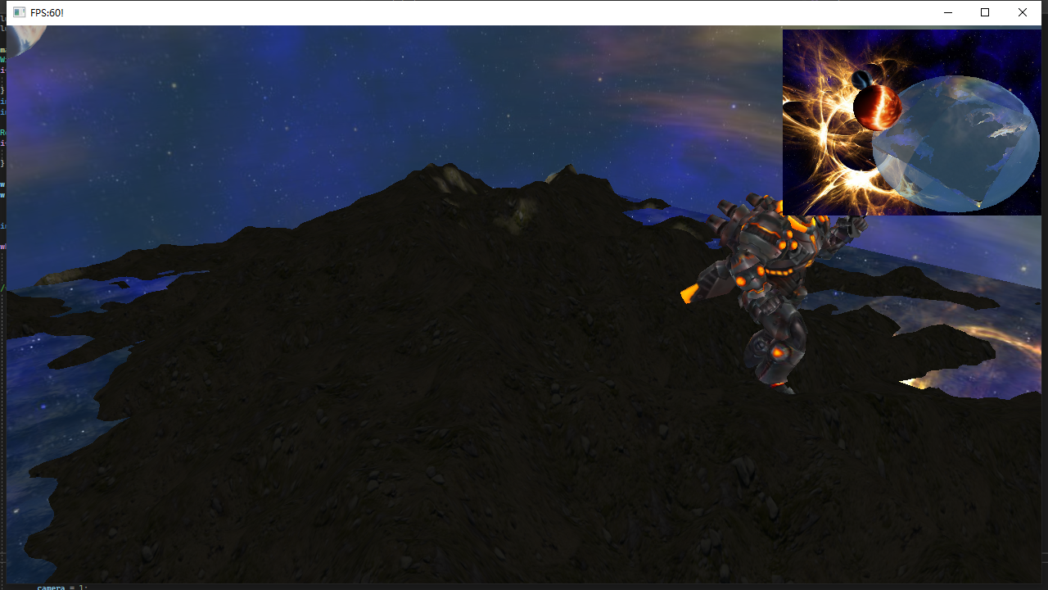

weather effects

